CASE STUDY: UPI/ONLINE PAYMENT FRAUD

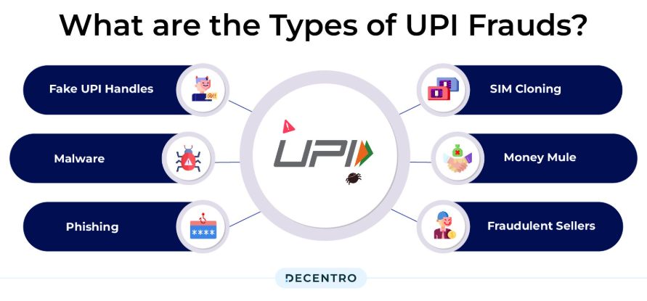
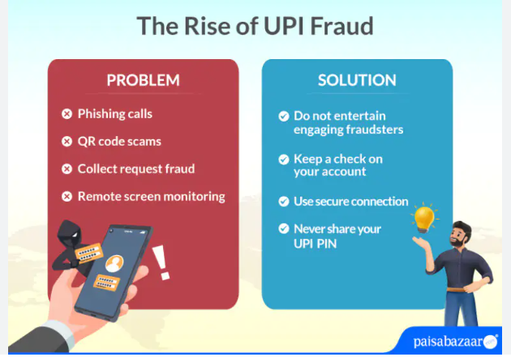

UPI/Online payment fraud is a type of cybercrime in which fraudsters deceive individuals into transferring money or revealing sensitive banking information such as UPI PINs and OTPs. With the rapid adoption of digital payments, this crime has become increasingly common among college students, working professionals, and even small business owners.

The fraud typically occurs in a structured manner. First, the scammer contacts the victim through a phone call, SMS, or social media, often posing as a bank official, customer care agent, or buyer. Next, they create urgency by offering rewards, refunds, or warning about account issues. The victim is then asked to click on a malicious link, scan a QR code, or approve a “collect request.” In some cases, they are tricked into sharing OTPs or installing screen-sharing apps. Once the victim complies, the fraudster gains access and transfers money instantly from the victim’s account.

Such frauds usually target individuals who are less aware of digital security practices or those who act quickly under pressure. Students and elderly users are particularly vulnerable due to limited awareness or trust in online interactions.

The consequences can be severe, including financial loss, emotional stress, and loss of trust in digital platforms. In many cases, recovering the lost money is difficult. Therefore, awareness, cautious behaviour, and adherence to basic cybersecurity practices are essential to prevent such frauds.

